TECHNICAL PROJECT REPORT

# Title of Invention / Project:

Ultrasonic Security

# Team Members / Inventors:

|  |  |  |  |  |  |
| --- | --- | --- | --- | --- | --- |
| **S.No.** | **Name** | **Department** | **Designation** | **Mobile** | **E-Mail** |
| 1. | Md.Faisal | CSE | Member | 9479287990 | faisalraza778866@gmail.com |
| 2. | Kamlesh Nehra | CSE | Member | 6378367927 | krrsl123@gmail.com |
| 3. | Suliman | CSE | Member | 8557020118 | Sliumansaae769@gmail.com |
|  |  |  |  |  |  |
| 5. | Khushal Thakur | ECE | Mentor | 9646030764 | khushal.thaur@cumail.in |
| 6. | Anshul Sharma | ECE | Mentor | 9478697475 | anshulsharma.ece@cumail.in |
| 7. | Kiran Jot Singh | ECE | Mentor | 9463909689 | kiranjotsingh.ece@cumal.in |
| 8. | Divneet Singh Kapoor | ECE | Mentor | 9878422653 | divneet.ece@cumail.in |

Section – 1 (IPR Related)

# Brief Abstract (500 words):

* The problem we solved by our project is the prevention of wastage of current electricity.

Using this technology we would only use the electricity when the sensor detects any human movement. This would help conserve resources and have a secure future.

* In this project we used a PIR Sensor which helps detect human motion completeing the circuit and hence lighting the light. Then the Relay module automatically re-sets the circuit and turn the light off when no human movement is captured any more.
* We would like to make our device more compact. We also want it to me affordable and easily accesable.

# Novel/Additional modifications that you can propose to improve upon drawbacks

* There are a number of home automation light sensor already existing in the market, but all of them are very expensive and not compact. They are also not able to work with old homes circuit.

We would like to reduce the build cost so that people could benefit out of this technology and conserve electricy.

# Advantages

* If we are successfully able to put in all our future ideas to out prototype we would be able to save a ton of electricity cutting down the expenses helping people save current and the govt. save resources. This step could be benfitial for the future generation.

# Block Diagram

(*Functional diagram depicting the flow of information in your system. Do not define exact components, only use generic terms. Must include modifications as well.)*

Relay Module

Microcontroller

(Arduino uno)

PIR Sensor

9V Bulb

Section – 2 (Real Project)

# Materials

* Arduinouno
* Relay Module
* Bulb
* PIR Sensor
* Jumper wires
* 9V Battery

# Circuit Diagram

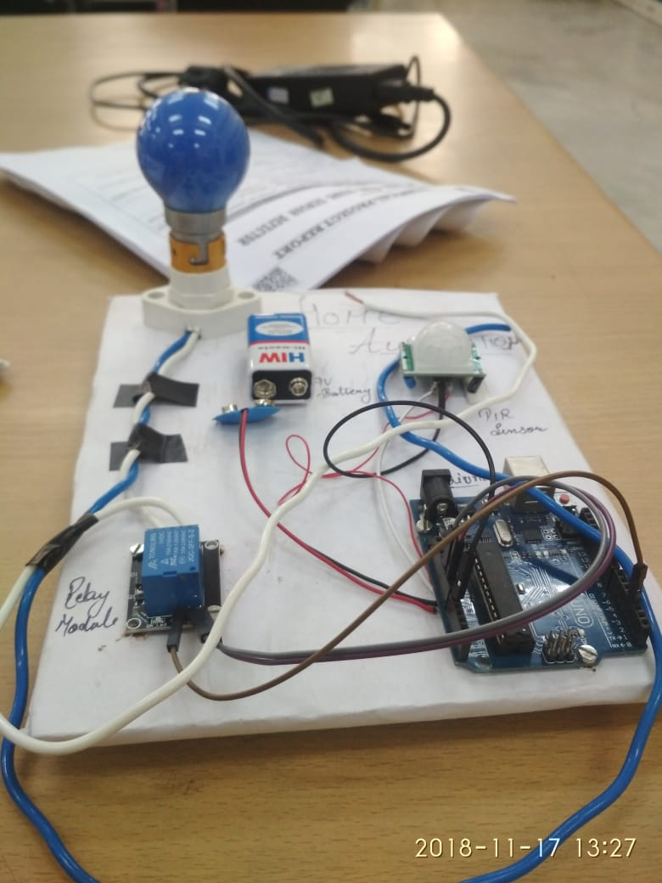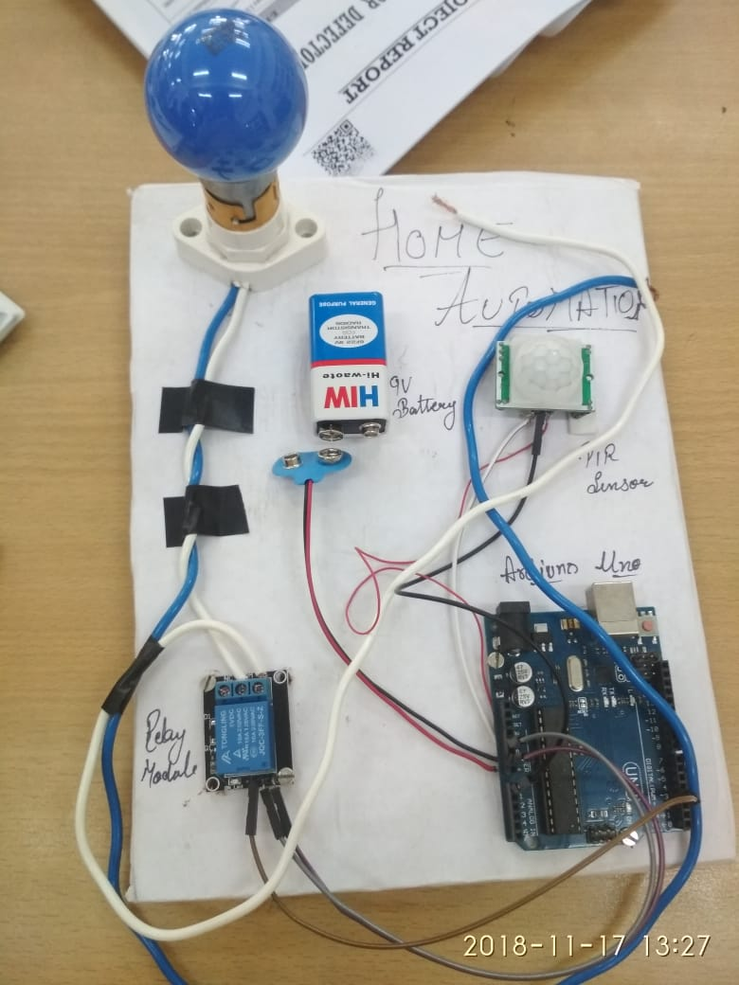

# Program Code

(*Link of your Github project*)